**Ex. No 1: Evidence Acquisition Using FTK Imager**

**Aim:** To capture RAM data and create a forensic disk image using FTK Imager **Requirements:**

* FTK imager
* Windows operating system **Description:**
* FTK Imager is a forensic acquisition tool used to create exact copies (disk images) of storage devices.
* It allows capturing RAM data, entire drives, or specific partitions without altering original evidence.
* Investigators use it to preview, preserve, and export data for further forensic analysis.

**Acquiring Volatile Memory (RAM) Using FTK Imager**

**Step-1:** Right click on the FTK imager tool and select run as administrator

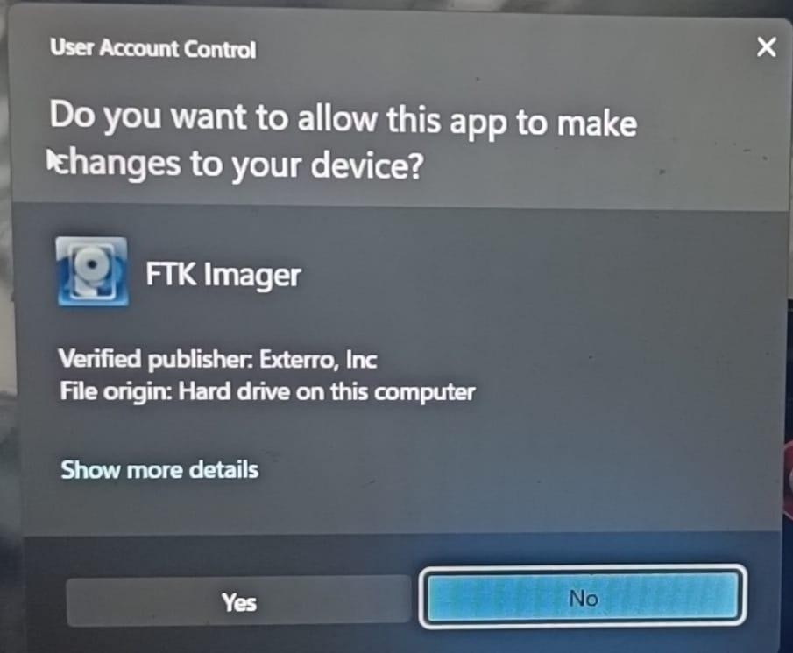

**Step-2:** On right top menu bar click file and select capture memory from drop down list

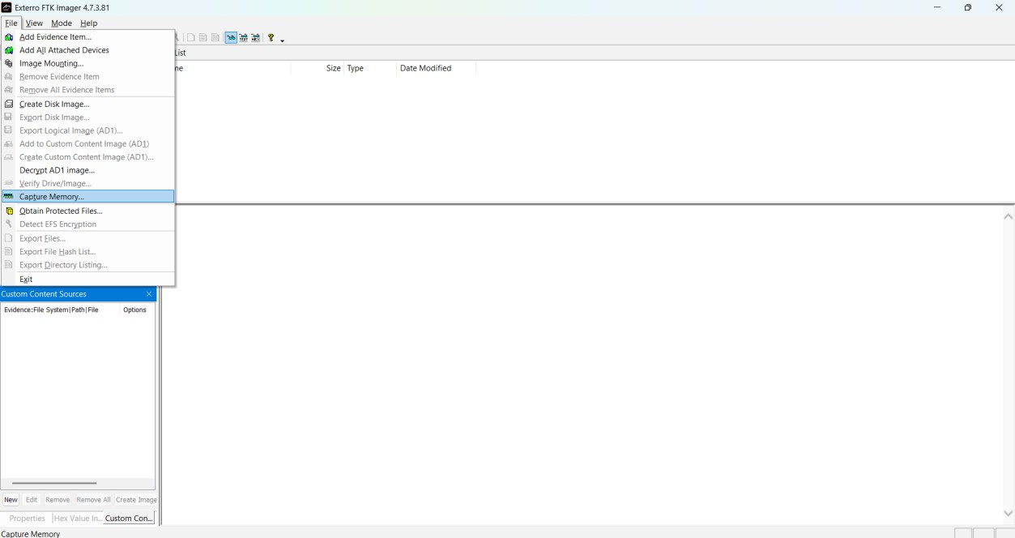

**Step-3:** A dialog box will appear select the destination path to your file and provide the file name with “mem” extension and pagefile and AD1 file are optional.

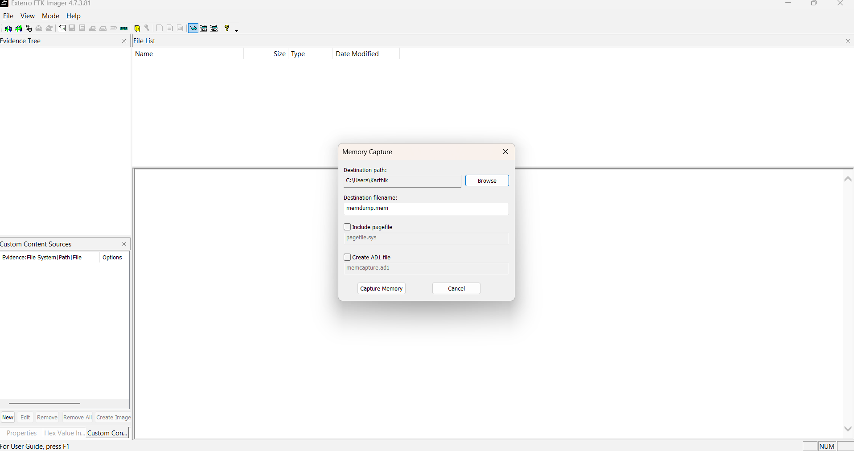

**Step-4:** click the “capture memory” to start acquisition of memory

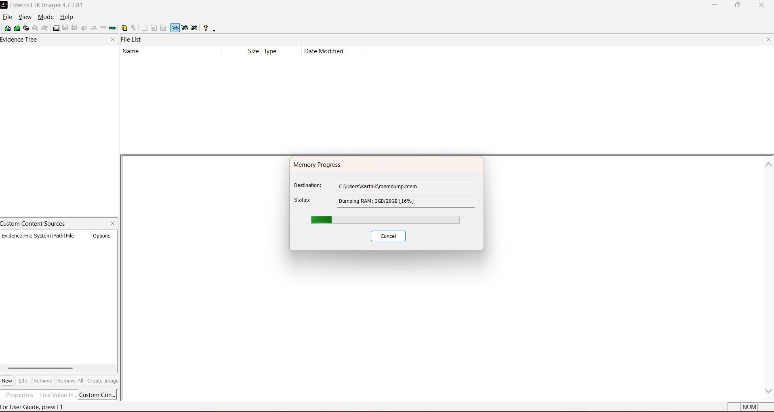

**Step-5:** A progress bar in green colour will indicate the capture status and the time taken to capture the RAM will depends on RAM size. After completion of capturing the memory dump file will be available in the destination folder

**Acquiring Non-Volatile Memory (Disk Image) Using FTK Imager**

**Step-1**: On the top right menu bar click file and select the “Create Disk Image” from the drop-down menu

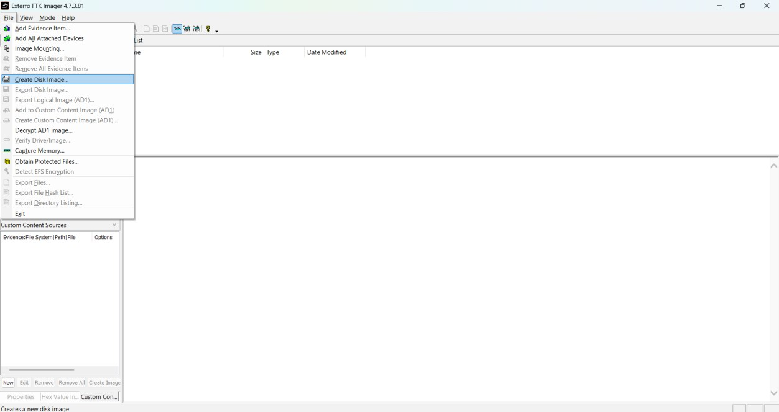

**Step-2:** In the dialog box, choose the source evidence type like Physical Drive, Logical Drive, Image File or Contents of a folder

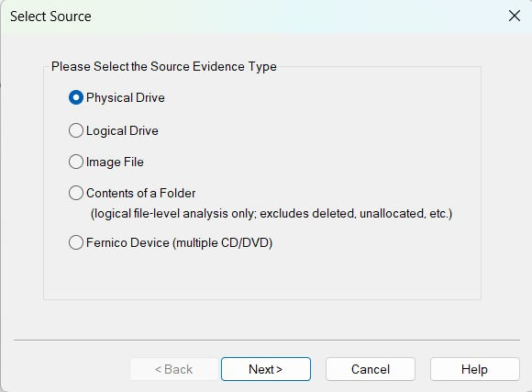

**Step-3:** Select the drive you want to image and click Finish

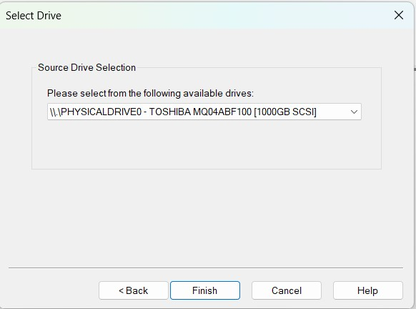

**Step-4:** In the “Create Image” dialog, click Add to define image type

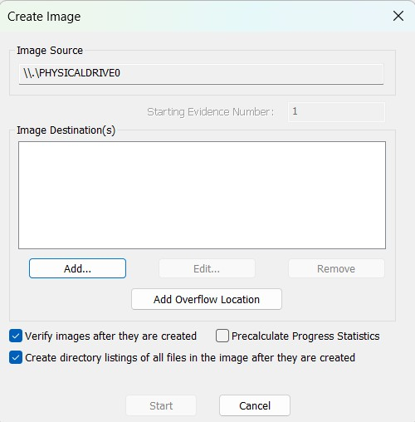

**Step-5:** Select the image type from the dialog box (Raw/SMART/E01/AFF) among all E01 is recommended

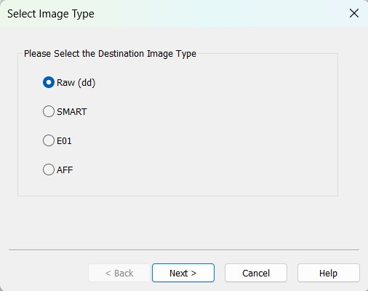

**Step-6:** Fill in the case information (case number, evidence number, examiner name, unique description and notes) click Next.

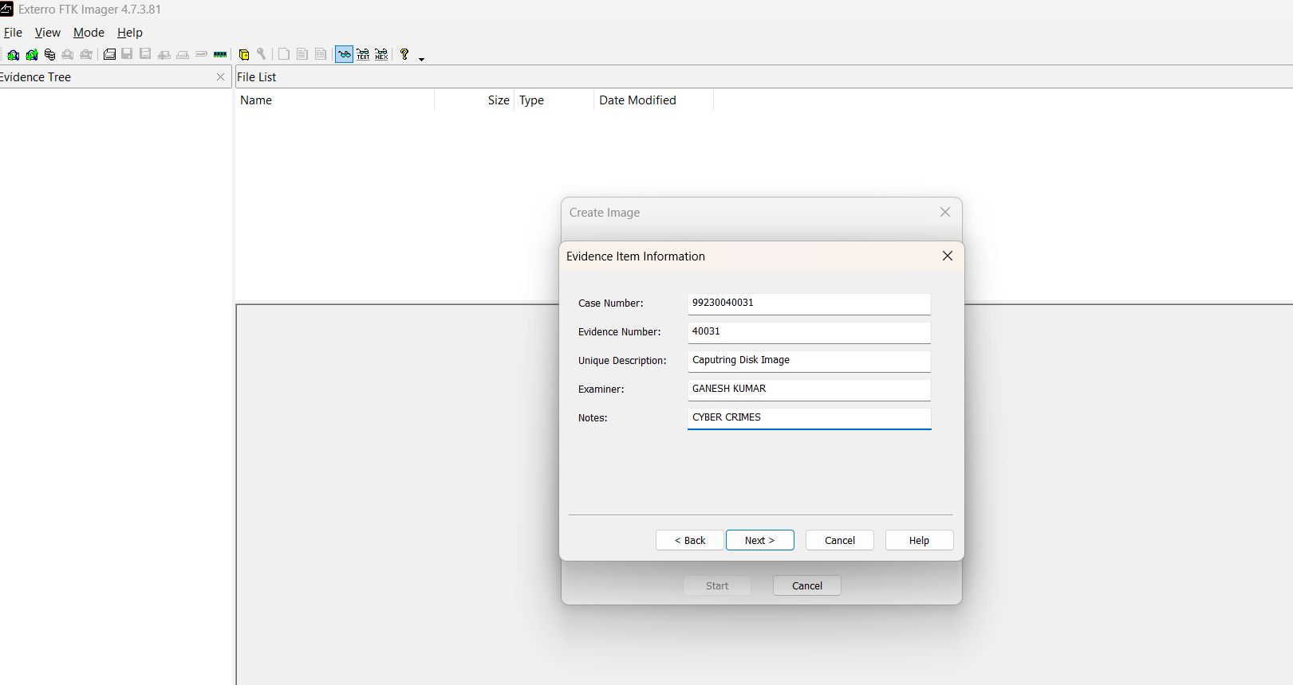

**Step-7:** Choose the destination folder and give a file name for the image.

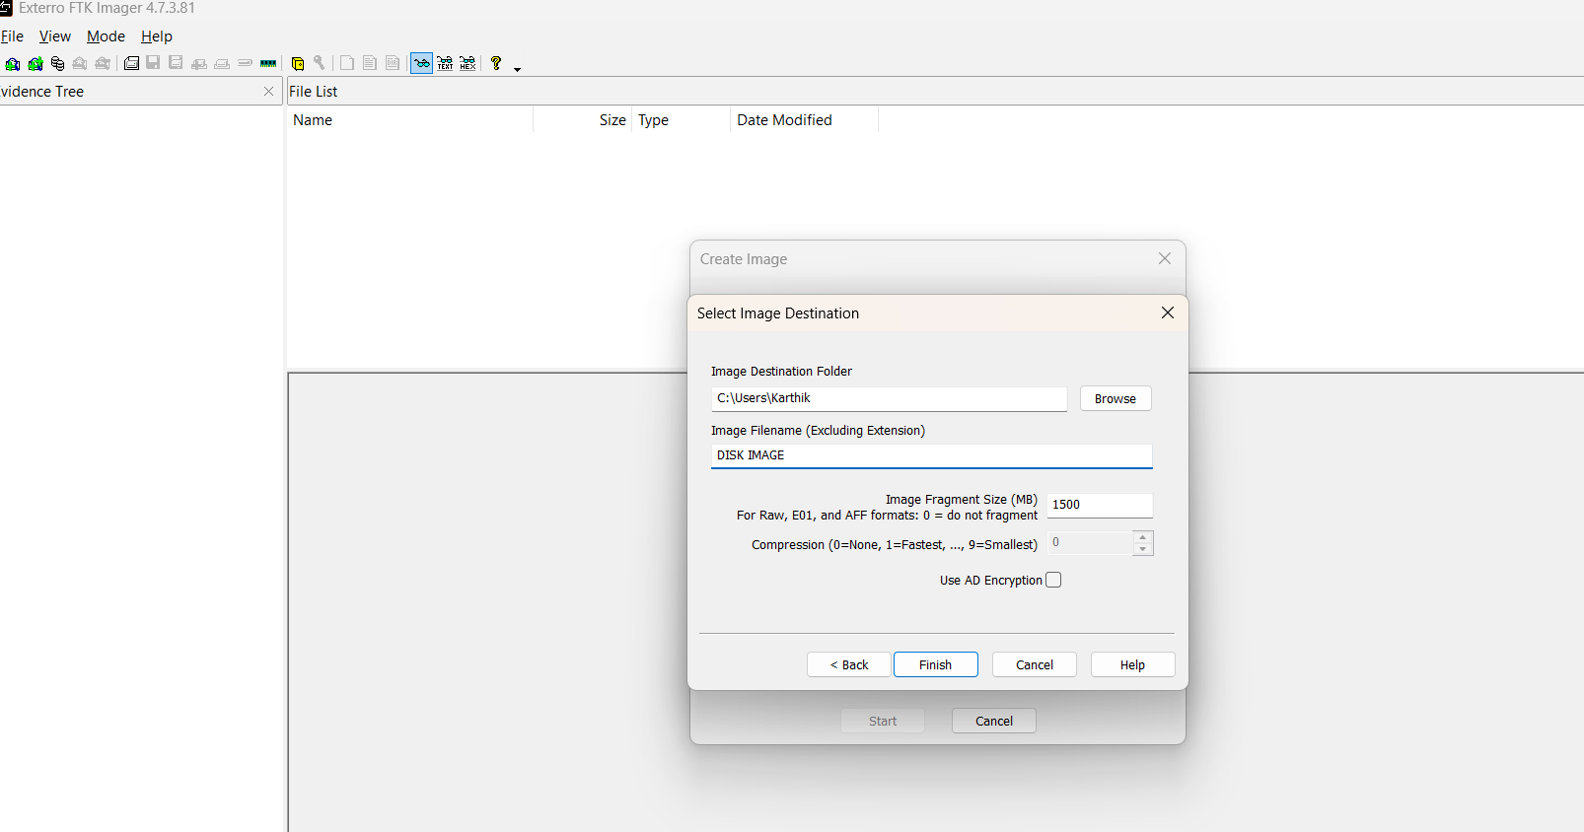

**Step-8:** Set options like compression, splitting size, and click Finish after that Start the imaging process.

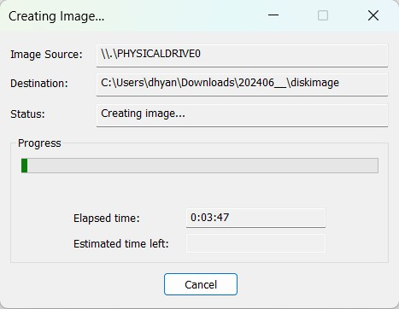

FTK Imager will display progress along with hash values. The imaging process may take time depending on the drive size. After completion, FTK imager verifies the hash values automatically and it maintains the forensics integrity.

Finally, the hash values are matched